Brush Strokes Test

Instructions: Write a full-page mini-narrative (story) based on any of the pictures at the bottom, and include all of the five grammar brush strokes (one of each). Consider details that are in the photo, as well as those you can’t see. Make sure that you annotate (identify/label) each of the different brush strokes in your story.

The brush strokes we learned are listed below, in case you may have forgotten. Additionally, the brush stroke word/words for each example have been boldfaced and italicized. YOU MAY NOT USE ANY OF MY EXAMPLES!

1. Action verb: verbs that specifically describe the action that the subject of the sentence is doing.
Example: Jesus obliterated the aliens with his XT-45000 ray gun.

2. Appositive: a noun that follows another noun and refers to the same thing. Appositives are separated from the rest of the sentence with commas.
Example: Dez Bryant, a frequent crybaby, was benched for his attitude during the 44-0 loss.

3. Participle: an ing word, or words, placed at the beginning or end of a complete sentence.
Example: Wailing and kicking, Robert was shoved into his English teacher’s tutoring session.

4. Absolute: a combination of a noun followed by a participle (an ing word).
Example: Alejandra quickly accepted Irvin’s invitation, her cheeks reddening and heart thumping.

5. Adjectives out of order: using three adjectives to describe a noun, with one adjective placed before the noun it modifies and two after.
Example: Yoseph kissed the shy brunette, a conservative and nervous girl, when she least expected it.

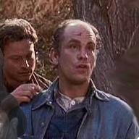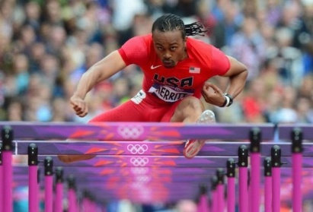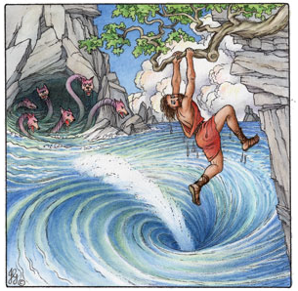

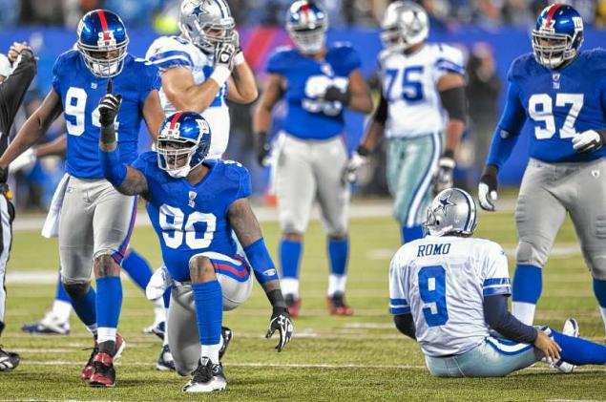

Photo credits (clockwise from top): Of Mice and Men (bookcoverimgs.com), Aries Merritt (lexpress.fr) Scylla and Charybdis (homelessmanspeaks.com), Jason Pierre Paul (nydailynews.com), Romeo and Juliet (theredlist.com.

